**A Project Report**

**On  
 UHG Specific Business Use Case**

Online Health Insurance System

Under the guidance of

**Harshwardhan Karkar,  
Prashant Bagare**

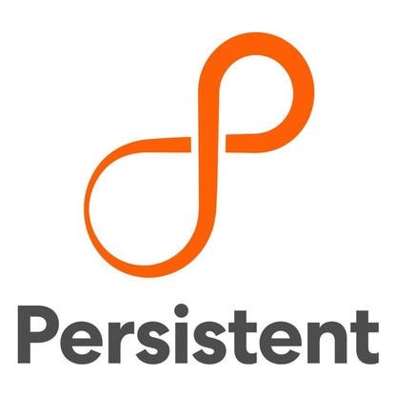

Team Members

|  |  |
| --- | --- |
| Name | Role |
| Prashant Mendhe | Backend |
| Varada Datar | Frontend |
| Pooja Guttal | Backend |
| Ashwini Kadadas | Frontend |
| Vinuta Jainapur | Backend |
| Veersagar Randive | Backend |

|  |  |  |
| --- | --- | --- |
| Sr. No. | Particulars | Page No. |
| 1 | **Introduction**   * Functional Requirements * Non-Functional Requirements | 3 |
| 2 | **Design**   * Use Case Diagram * Data Flow Diagram * ER Diagram | 6 |
| 3 | **Implementation**   * Frontend Implementation * Backend Implementation | 10 |
| 4 | **Testing**   * Frontend Testing * Backend Testing | 28 |
| 5 | **Future Scope** | 34 |
| 6 | **Limitations** | 34 |

**Introduction**

* **What is Health Insurance System?**

A health insurance is designed to provide financial assistance to the policyholder in case he/she incurs a covered medical expense. In return, the policyholder is required to pay a premium regularly. The medical expenses are covered up to the sum insured limit, which is the maximum claim amount provided by the insurance company.

## Popular Health Insurance Companies:

1. Aditya Birla Health Insurance
2. Care Health Insurance
3. Digit Health Insurance

* **Functional Requirements:-**
* **Tools Used**
* Any IDE (STS)
* Visual Studio Code
* MySQL Database
* Postman
* GitHub – collaboration
* **Technologies Used**
* **Frontend**
* React Js
* Redux
* JavaScript
* Material UI
* **Backend**
* MySQL
* Spring boot
* Spring security
* Spring cloud API gateway
* Hibernate

**Non-Functional Requirement: -**

1. **Availability**

The system must be accessible for a user at a given point of time.

* User requires a good Internet connection to access the application from anywhere

**2.Security**

Assures all data inside the system or its part will be protected against malware attacks or unauthorized access.

**Example**

* The User details gateway must be secure using the security framework like in spring we use Spring Boot Security for user authentication, authorization

**Spring Security for Project: -**

* The API Gateway will incorporate the inclusion of spring security.
* Spring Security is a powerful and highly customizable authentication and access-control framework.
* It is the de facto standard for securing Spring-based applications.
* Because the microservices operate on distinct ports, their access is exclusively through the API gateway.
* Therefore, by ensuring the security of the gateway, we can effectively protect all the microservices.
* We can use them to ensure the security of user details and at the order process part.

**The Security Part we have implemented in the Project are**:

**JWT Token:** - Used JWT Token (A JSON web token) in the project for the authentication of user. We are passing authenticated JWT Token of user to every APIs to get access to it.

**OTP Verification** :- Implemented OTP based email verification while user resetting a forgot password or new password. OTP will be sent to registered Email id user only. After entering correct OTP, user have access to reset the forgotten password.

**Text Based Captcha**:- Implemented a text-based captcha in user registration page to differentiate between real website users and automated users such as bot.

**Design**

* **Use Case Diagram: -**

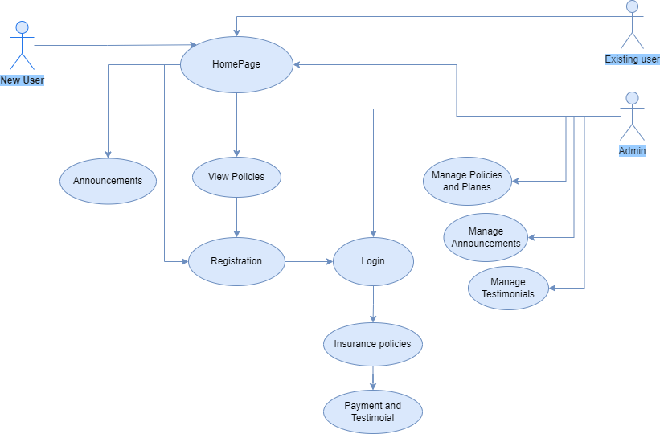

**The Use Case Diagram flow is like**

**Use Case Name:** Online Health Insurance System

**Actors:**  New User, Existing User, Administrator

**Goals:** Registration, Login, View policies, manage policies and plans, manage announcements, manage testimonials and claim policy

**Precondition:**

It applies to all(registration, login, view policy , claim policy,& manage policy ,announcements,testimonials)

=>The user must have an active session

=>The user can see all the insurance policies in the home page itself

**To  Registration :**

**Postcondition for Registration:**

**Basic Flow:**

=> User open their Health insurance System

=> After Registration, there will be user login page and admin login page

**To  Login :**

**Postcondition for Login:**

=>To login, User must be present in the database  
=>To login, Admin must be present in the database

**Basic Flow User:**

=> If user login into the system, then he can see user navbar.  
=> user can view plans, announcements and he can see claimed policies under his/her profile.

=> user can claim any policy which are displayed in the policies section

**Basic Flow Admin:**

=> If Admin login into the system he can add the plans ,policies, admins and   
he can approve testimonials   
=>he can also manage users (he can add or delete the user)  
=>Admin can interchange the position of menu, banner, announcement positions

**Data Flow Diagram - USER: -**

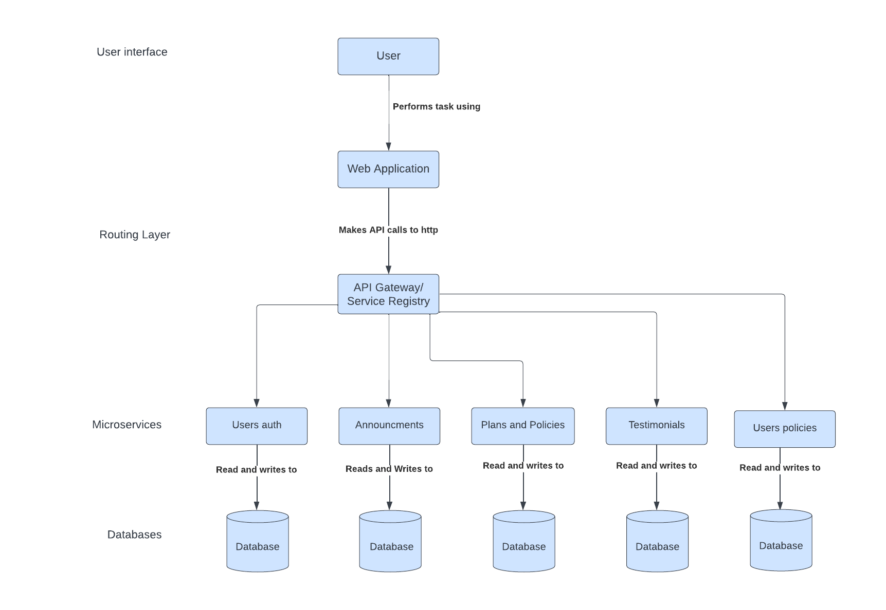

**Data Flow Diagram - ADMIN:-**

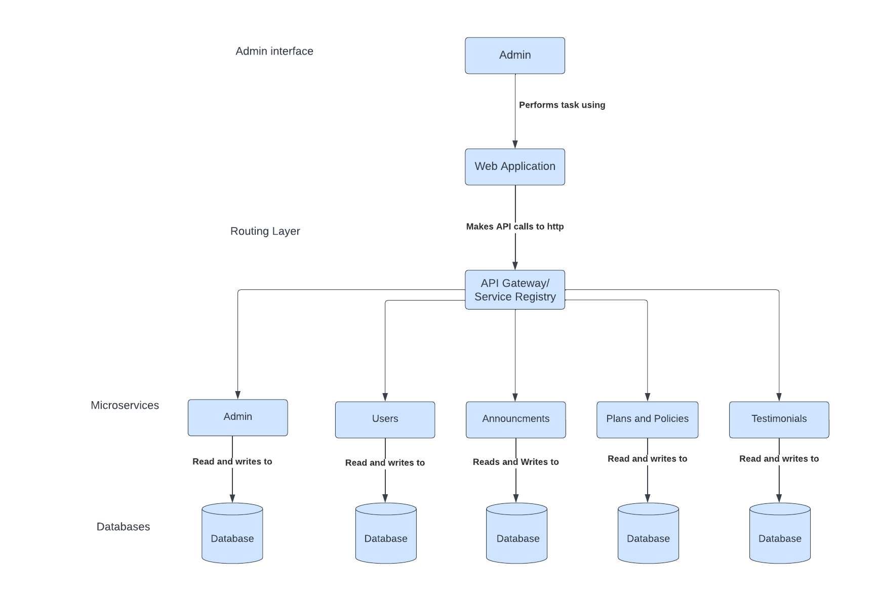

**Data Flows**:- Represented by arrows, data flows depict the movement of data from one component to another. They show the direction in which data is passed and can be labeled to indicate the specific data being transmitted.

**External Entities** :- Represented by squares or rectangles, external entities represent external sources or destinations of data. They can be people, organizations or other systems that interact with the system being depicted in the diagram.

* **Entity Relationship Diagram (ER Diagram) :-**

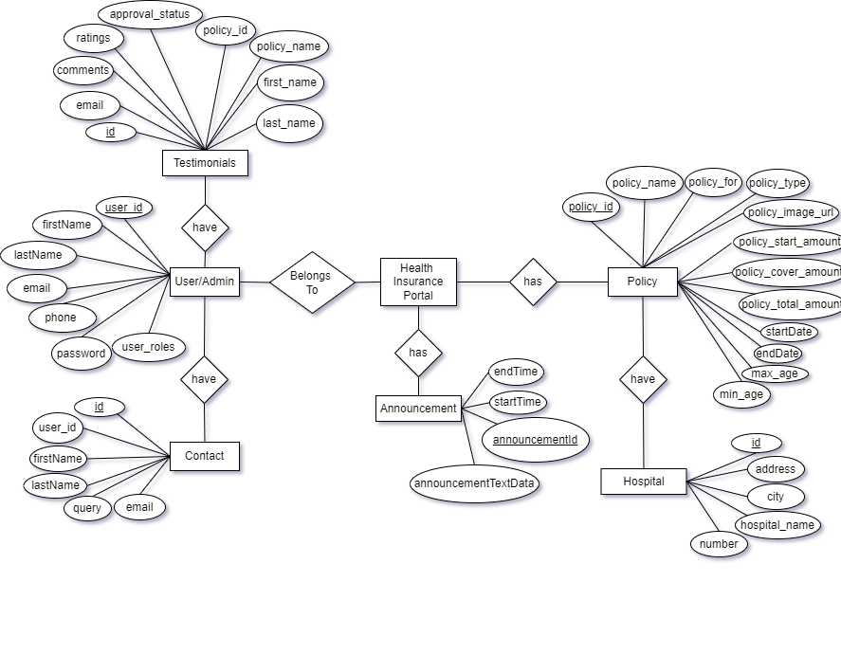

**Main components and its symbols :**  
Rectangle: It represents Entity type.  
Diamond: It represents the relationship.  
Lines: It links attributes to entity types and entity types with other relationship types.  
Primary Key: Attributes are underlined.

**Implementation**

**Frontend Implementation :-** Used React Js library and material UI for creating interactive User Interface.

**Homepage :-** Landing Page of Health Insurance System contains Banner with multiple images and slogans. It’s also display list of the Announcements which admin has made. Recent announcement will be displayed at top. Homepage also includes list of health insurance plans with their details.

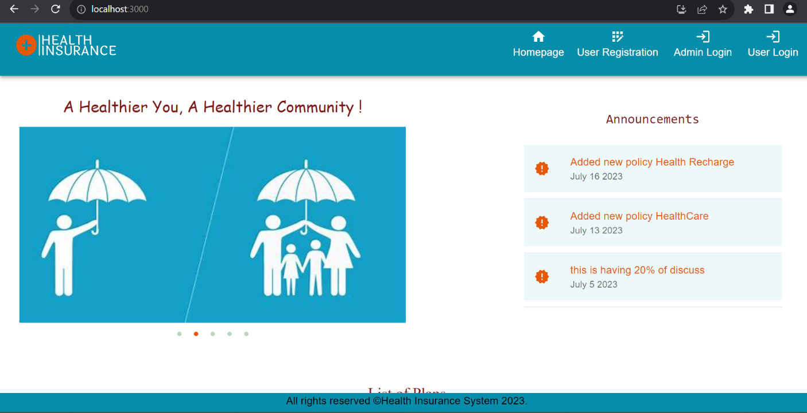

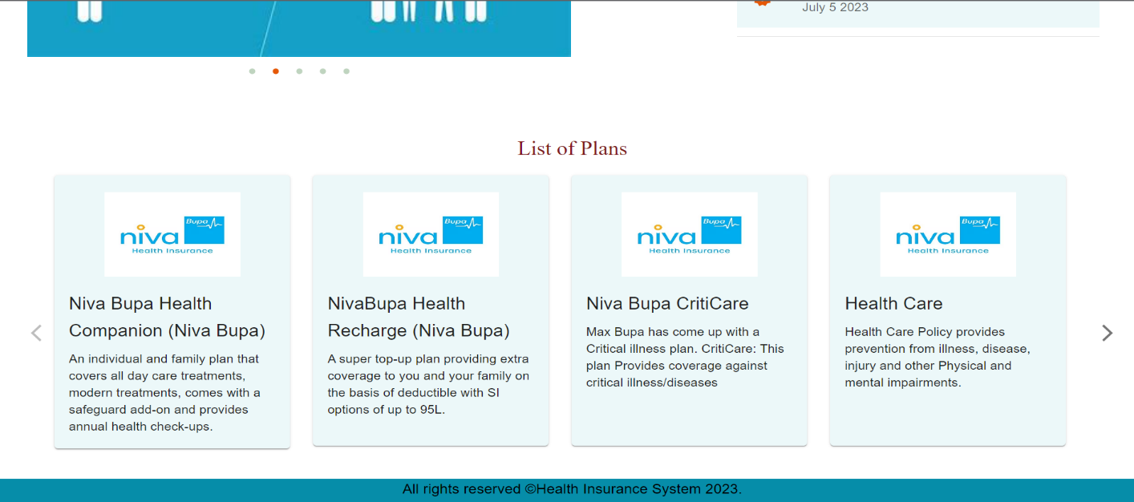

**User Registration Page :-** After clicking User Registration option which is present at top right side of header, Registration page will be displayed. User can register with the website by entering all required details accurately.

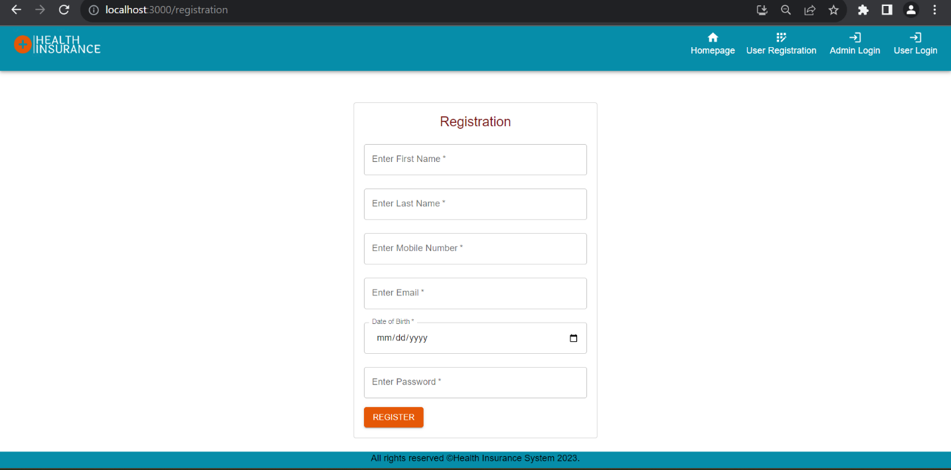

**Login :-** There is a separate login for user and admin.

**User Login :-** After successful registration, user can login to the website, by entering their email and password which have provided by the user during registration. Entering correct captcha is mandatory while login.

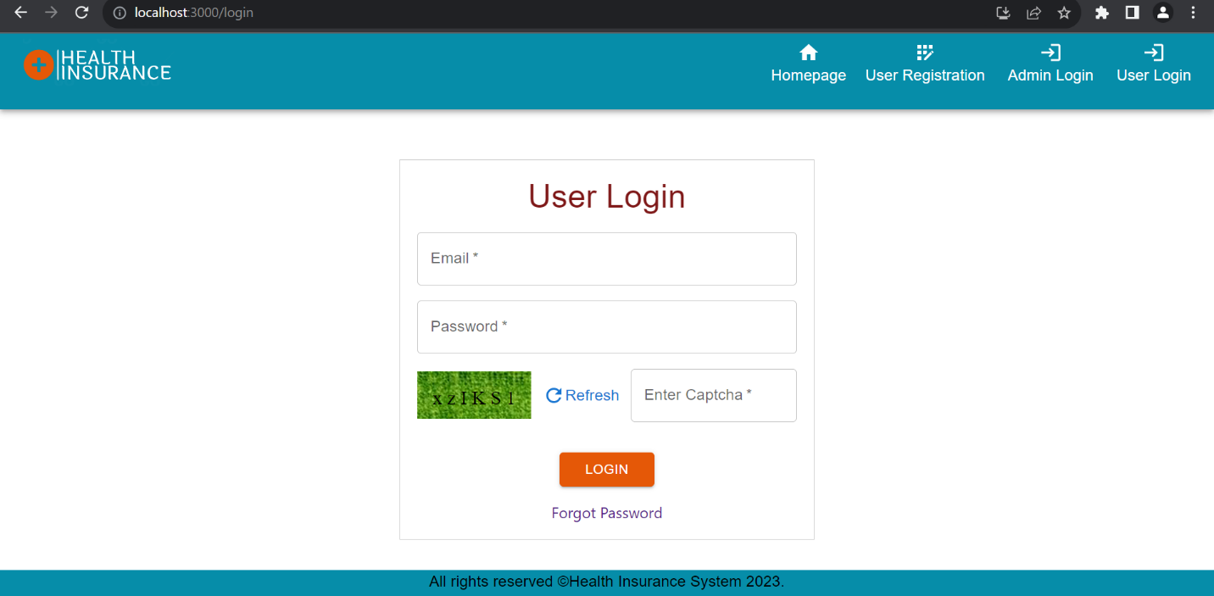

**Admin Login Page :-**  Admin can login to the website by entering their correct email Id and password. Entering correct captcha is mandatory while login.

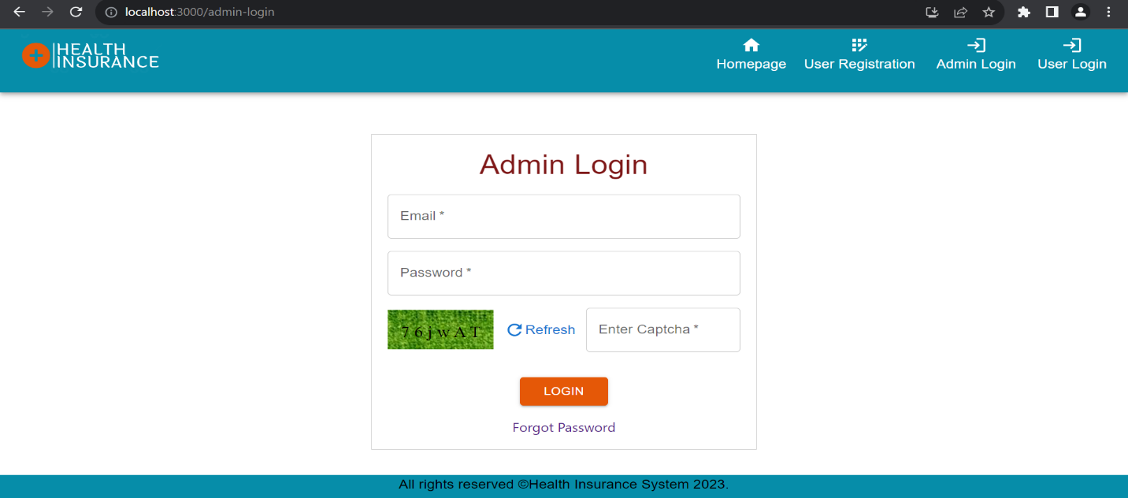

**Admin Menubar :-** After successful login, admin can see dashboard which contains menubar, banner, announcements and list of plans. Admin can see the menubar which includes options such as Arrange Position (To arrange the position of menubar, banner and announcements), Add admins (Admin can add other admin), Add plans/policy, view plans, Network Hospital, Approve Testimonial, Add announcements, Manage Users.

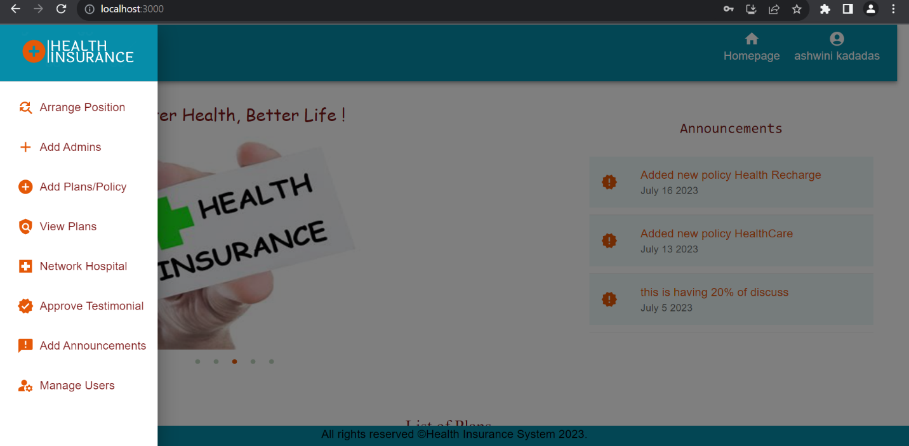

**User Menubar :-** After successful login of user, user can see dashboard and Menubar which contains options such as View Plans (For viewing all health insurance plans with their detailed description), My Policies (here the purchased policies will be displayed which user have been claimed), Network hospital (viewing all network hospitals), View Profile (user can see their profile) and Contact Us (Contact us Page where user can ask any queries related to website and claiming policy).

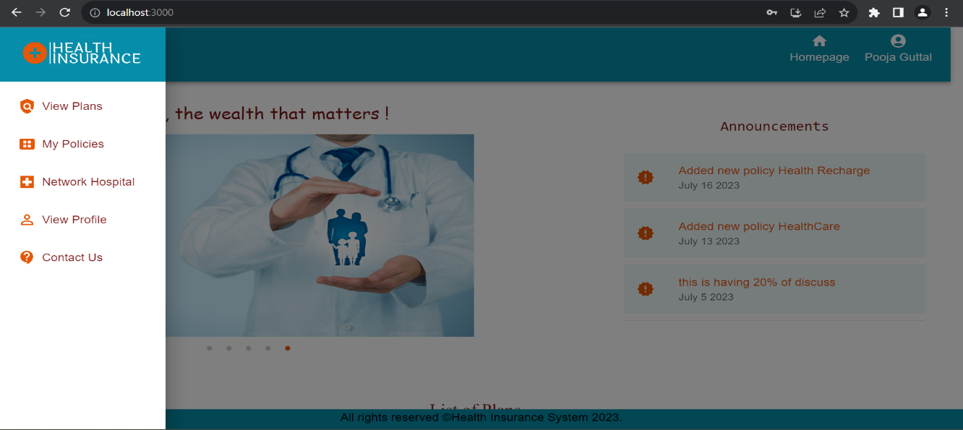

**View all Plans Page :-** After clicking view plans option in menbar, user can see all the health insurance plans and at the bottom user can see testimonials (reviews on plans given by other users ) . User can search the plan based on policy type and policy for option.

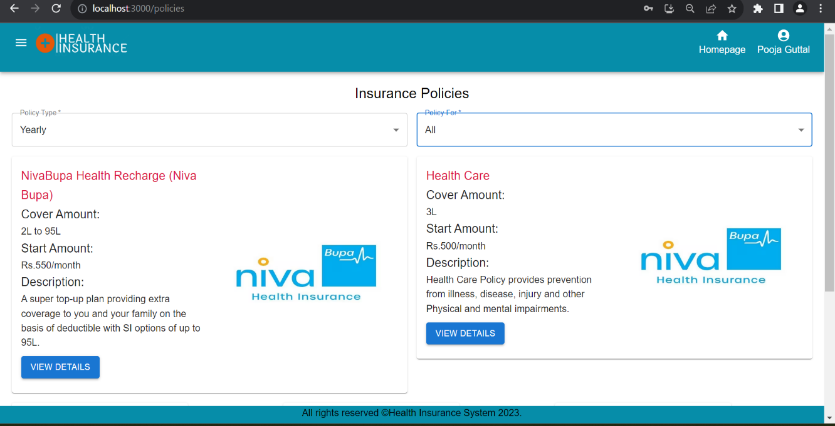

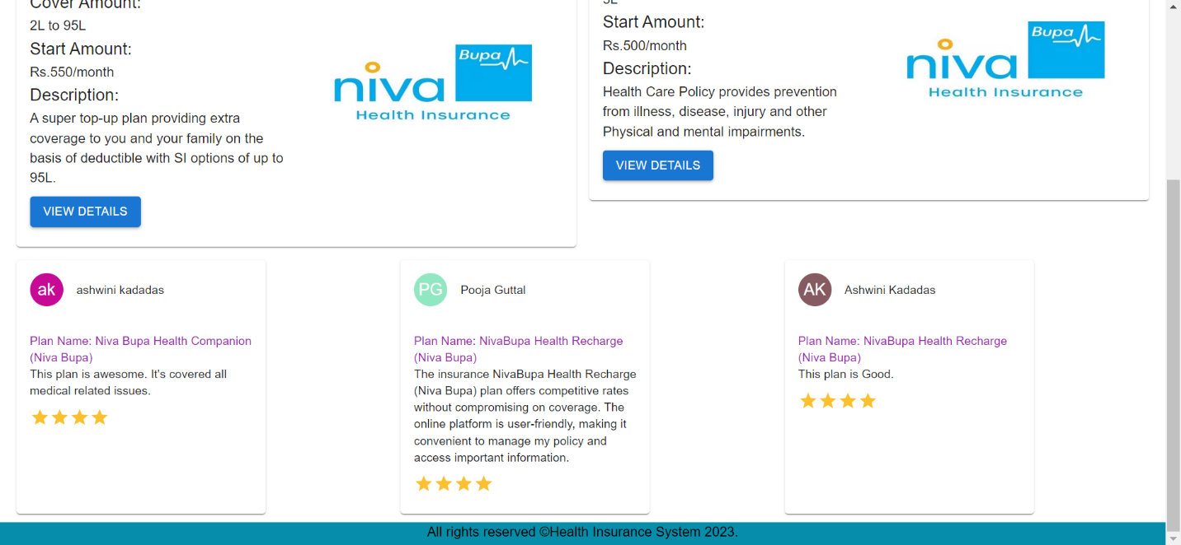

**Policy Details Page :-** After clicking View Details button present in the plans, Policy Details page will be displayed with detailed description of the policy. In this page there are 3 buttons- Back, Download & Print and Claim. By clicking Back button user can navigate to back page.

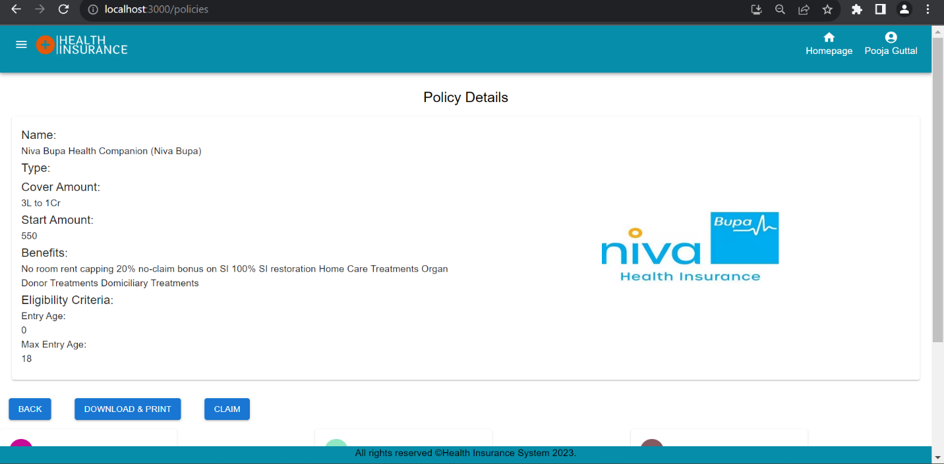

On clicking Download & Print button, user can download the policy details in pdf format and also user can print the details.

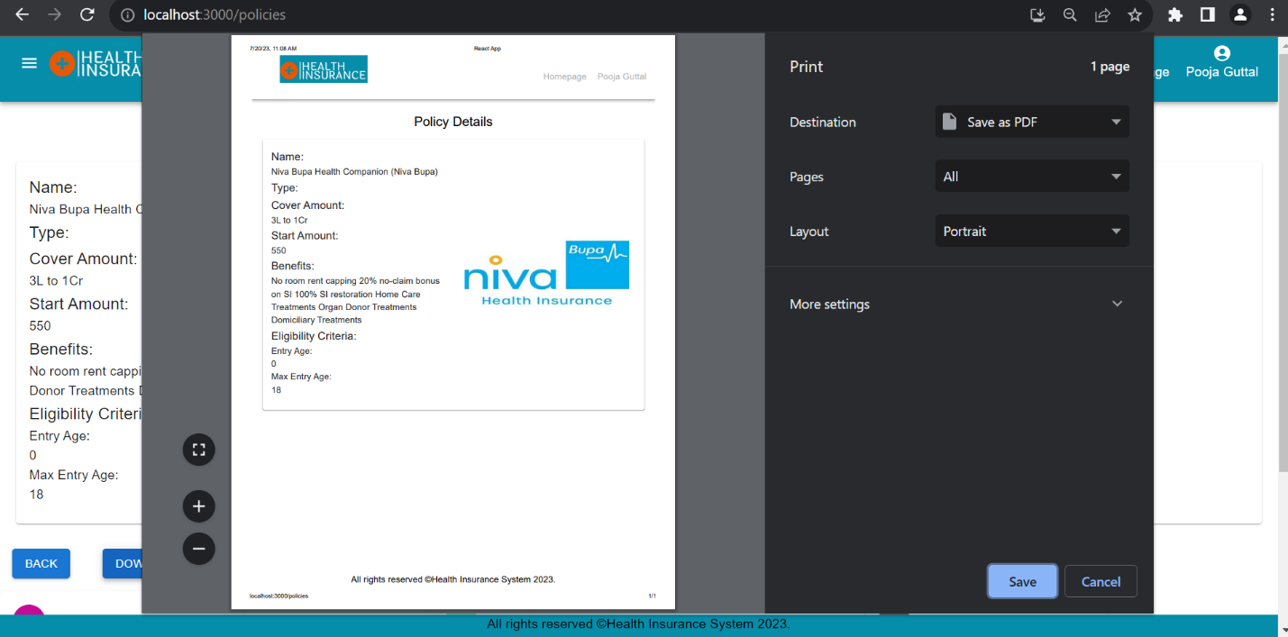

On clicking the Claim button, user can claim the policy. The payment Gateway will open with options of making payment. Right now, the UI is there, actual payment gateway is not integrated.

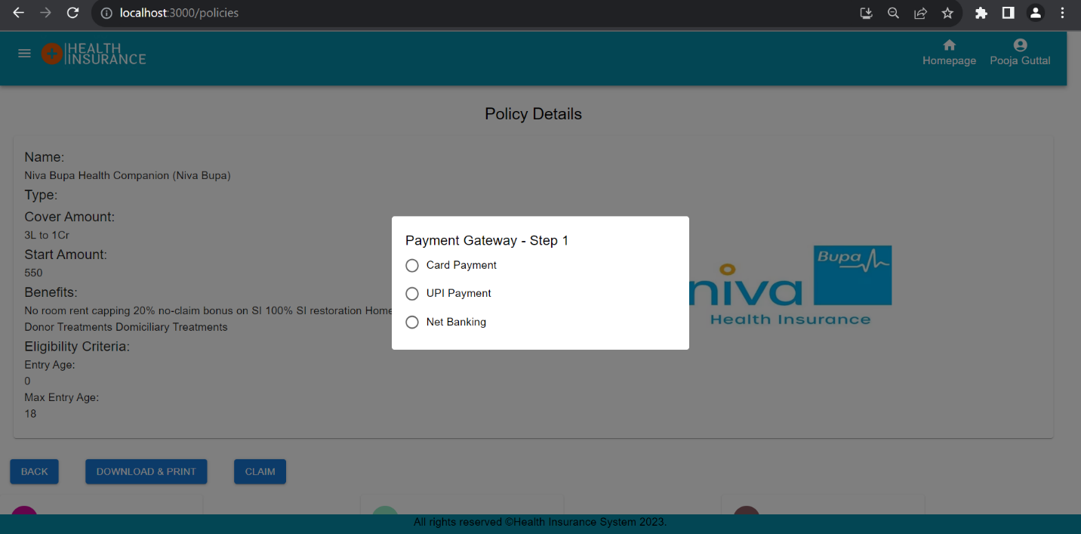

**View My Policies Page :-** After clicking My Policies option in menubar, Purchased Policies page will be displayed, This page display all the policies which user has purchased or claimed. There are 2 buttons present with policy details- View Details and Give Review. On clicking View Details button, The policy details page will be display.

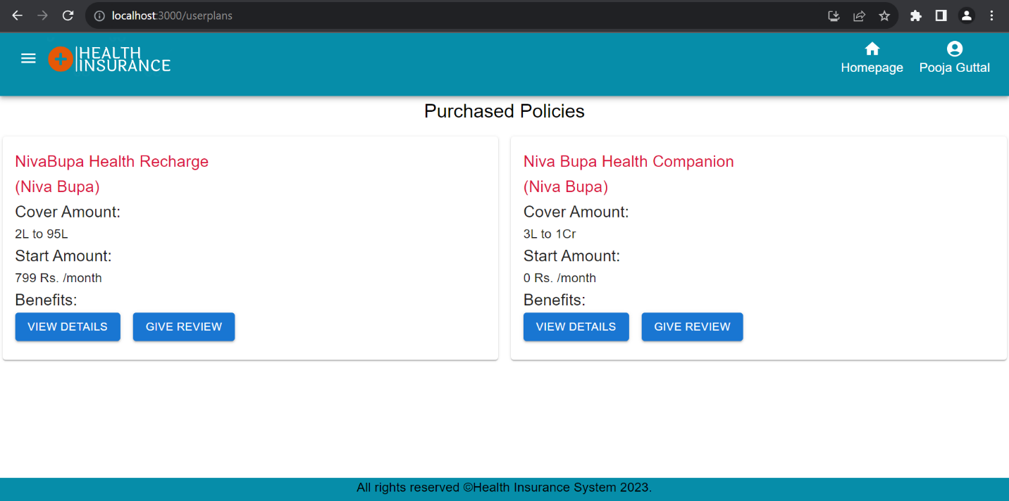

**A Review Page :-** On clicking Give Review button, a review page will open. In this page**,** auser can write a review on plan/policy which user has claimed. User must write a comment and give rating accordingly.

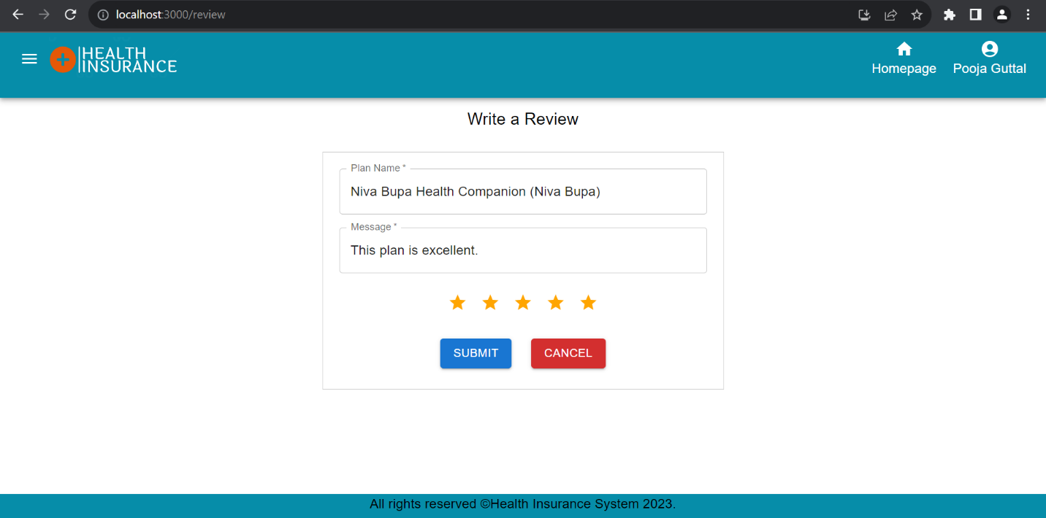

After successful submission of a review, a success message will be displayed at top.

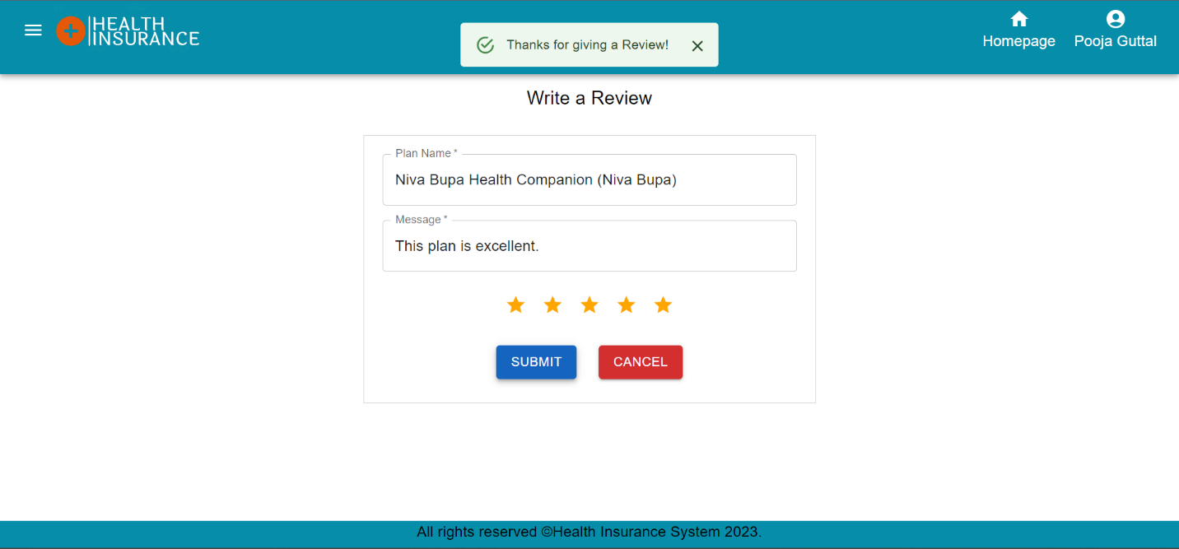

**Testimonial Approval Page :-** After successful submission of a user review, a request will be sent to Admin for approval. Admin can see Testimonial Approval Page by clicking on Approve Testimonial option in Admin Menubar. Admin can Approve or Reject the Testimonial request.

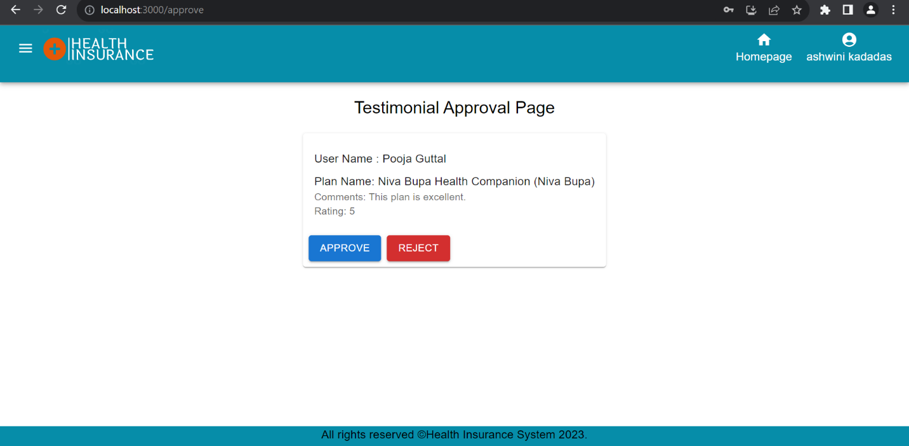

After Admin approved the testimonial request from the user, that testimonial will be visible in view plans page. If admin reject the review request then that testimonial review will not be visible in view plans page. Testimonial will be visible when only admin approved the user review.

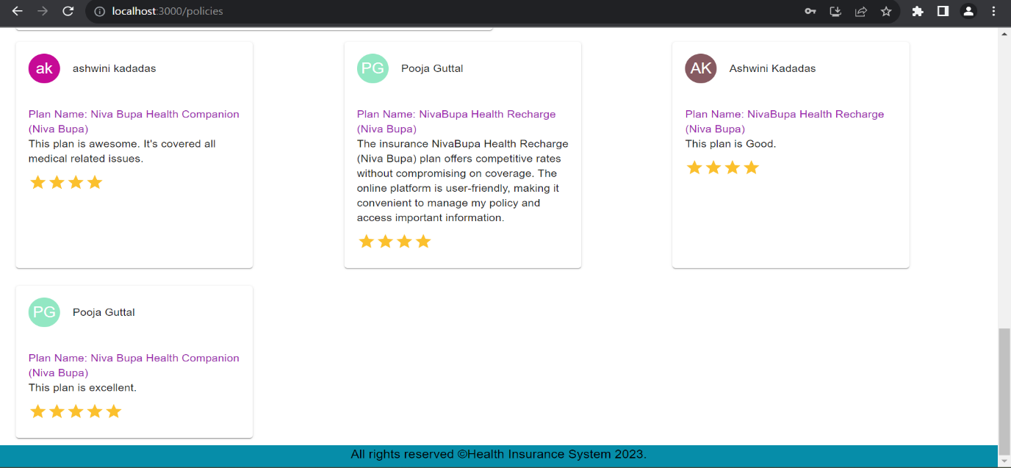

**Add Announcement: -** Admin can add new announcement so that users will be get updated with the latest changes. In admin menubar by clicking on add announcement option, the announcement page will display. Here admin can made new announcement by entering announcement-message, announcement-start time and announcement end time. After successful submission, alert popup will be displayed at top. 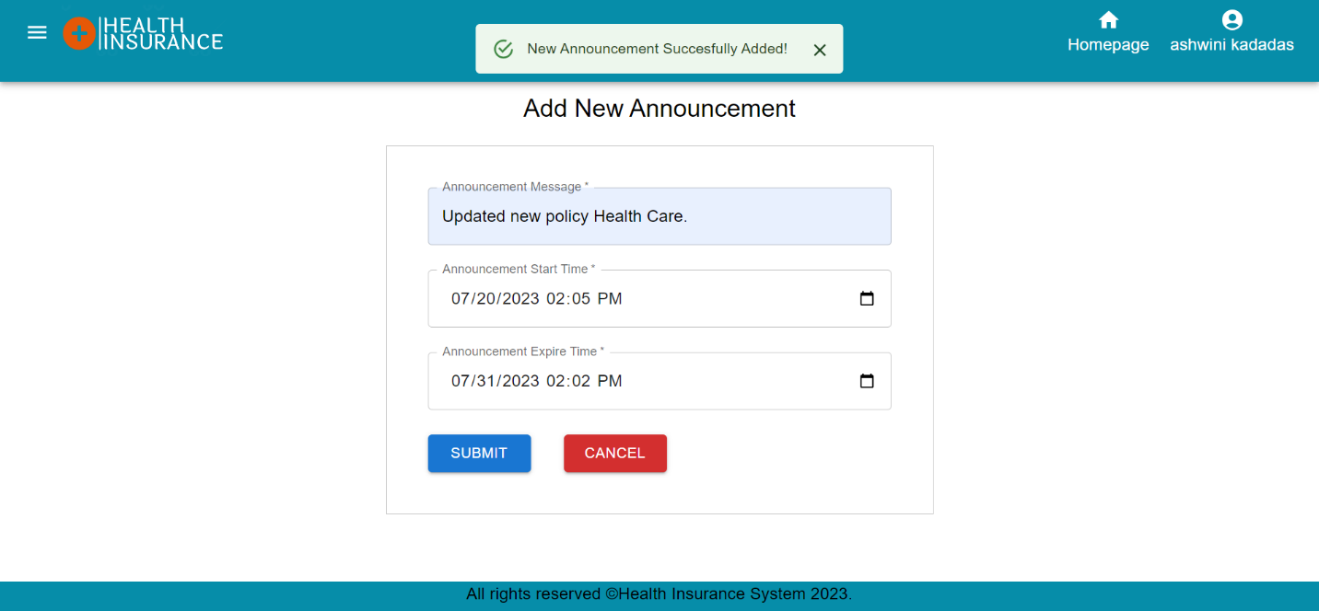

When announcement start time is equal to or greater than current time then those announcements will display in the homepage in announcement section.

If announcement end time is equal to or greater than current time, then those announcements will not display here. They will get deleted automatically from backend.

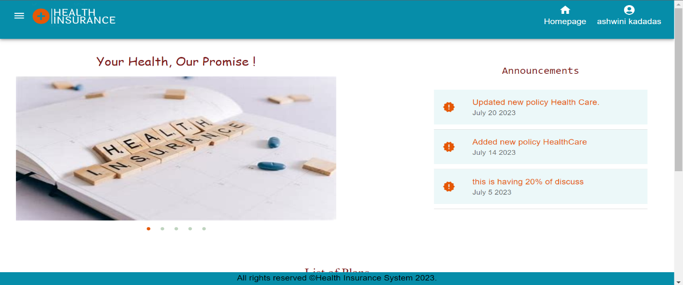

**Arrange Position: -** Admin can arrange or interchange the position of Menubar, Announcements and Banner by clicking on Arrange Position in menubar. In this page, admin can select the position of items. If admin choose announcements as Bottom Left then Banner will be automatically goes to Bottom Right or vice versa. If admin selects Banner as Top Right, then announcements move to Top Left or vice versa.

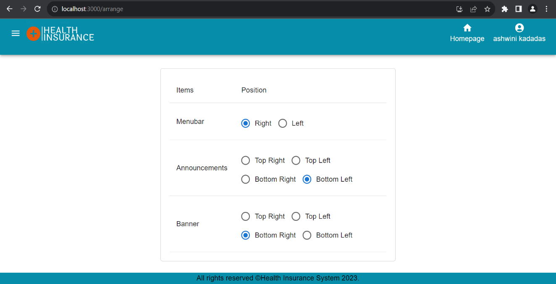

According to the above options selected by admin, the menubar will be display at right side of page as shown in below picture.

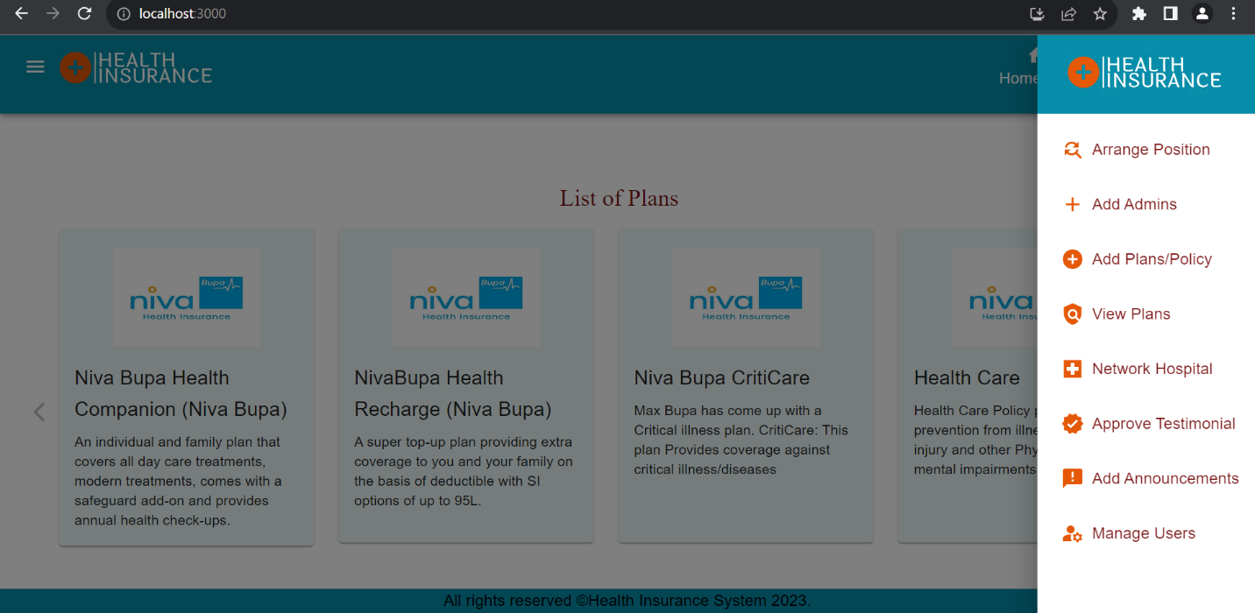

As admin selected the announcements position as Bottom Left so Banner will automatically move to Bottom Right.

List of Plans will be at Top side of page if Banner and Announcements are at the bottom of page.

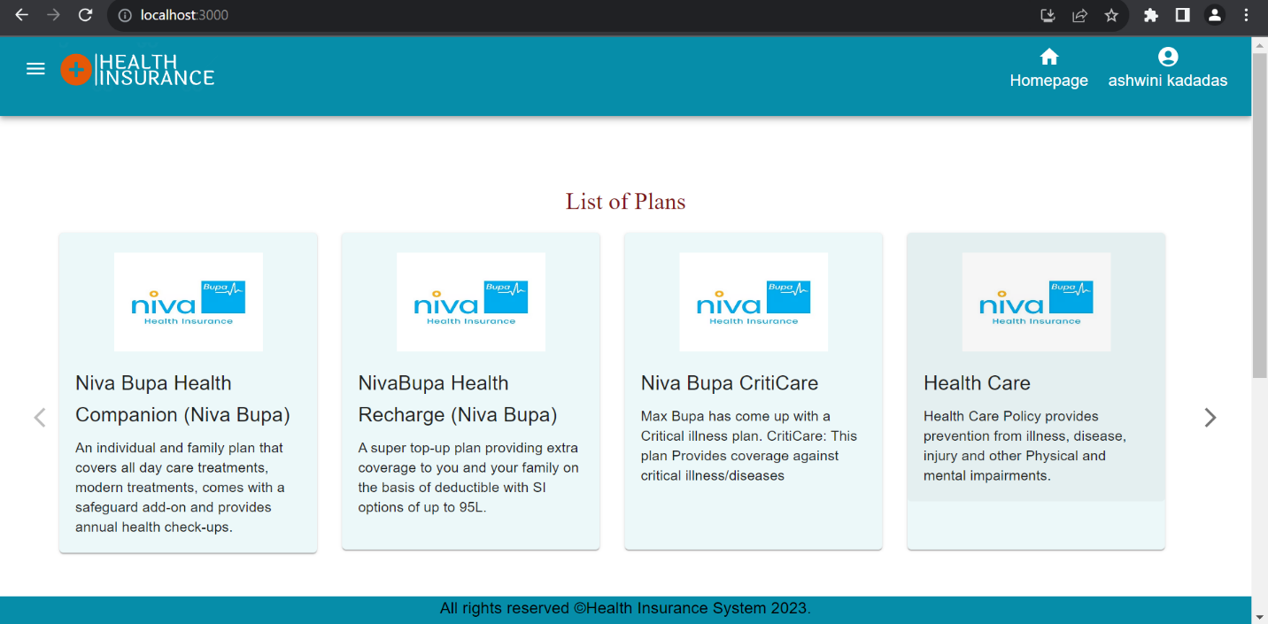

Announcements will display at Bottom Left side of page and Banner will moved to Bottom Right side of page. Announcements and Banner position get interchanged as shown in picture.

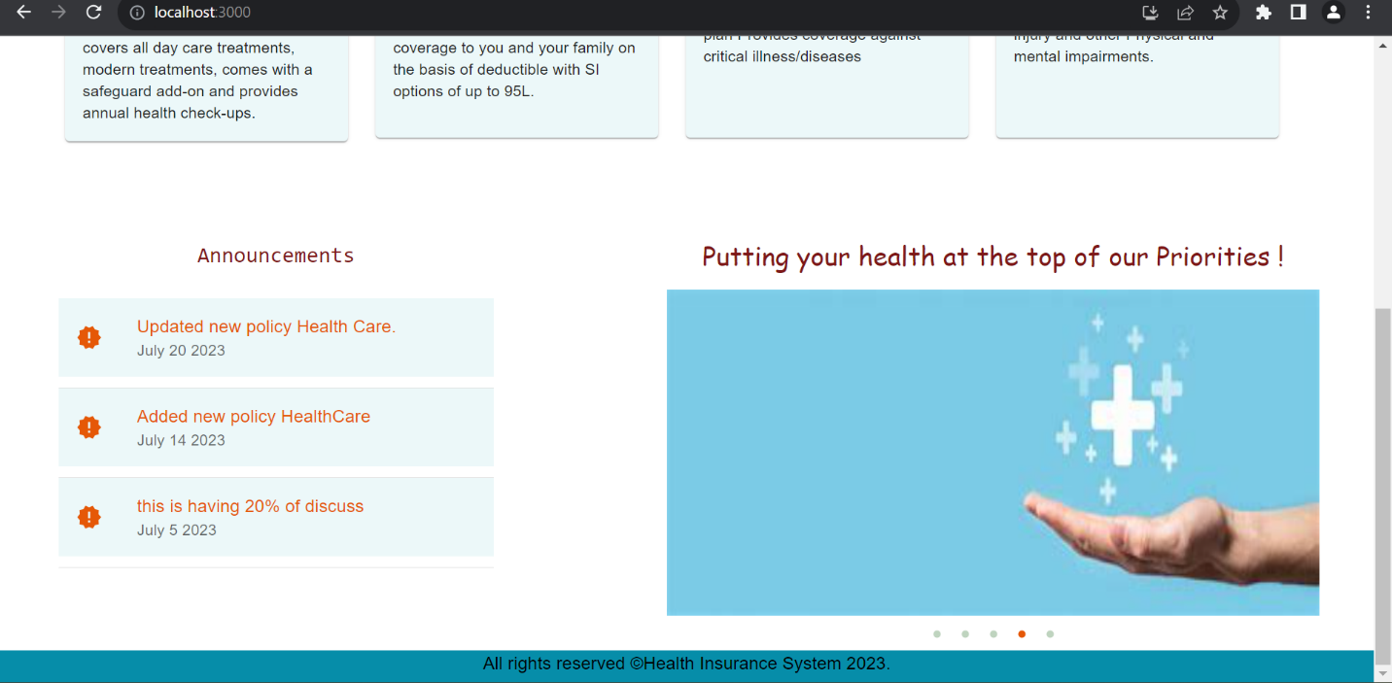

**Add Plan/Policy page: -** Admin can add new plan or policy by clicking on Add Plans/Policy option in menubar. After successful addition of new policy, that policy will get added in database.

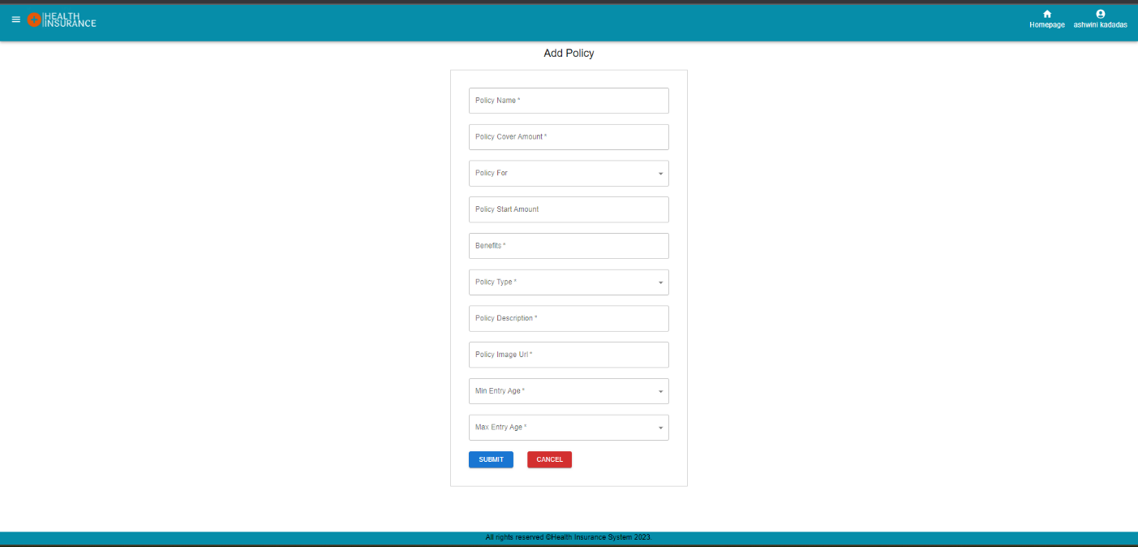

**Network Hospitals: -** Admin and User can view all the network hospitals list.

By clicking on Network Hospital option in admin menubar and user menubar, the Network Hospitals page will be visible.

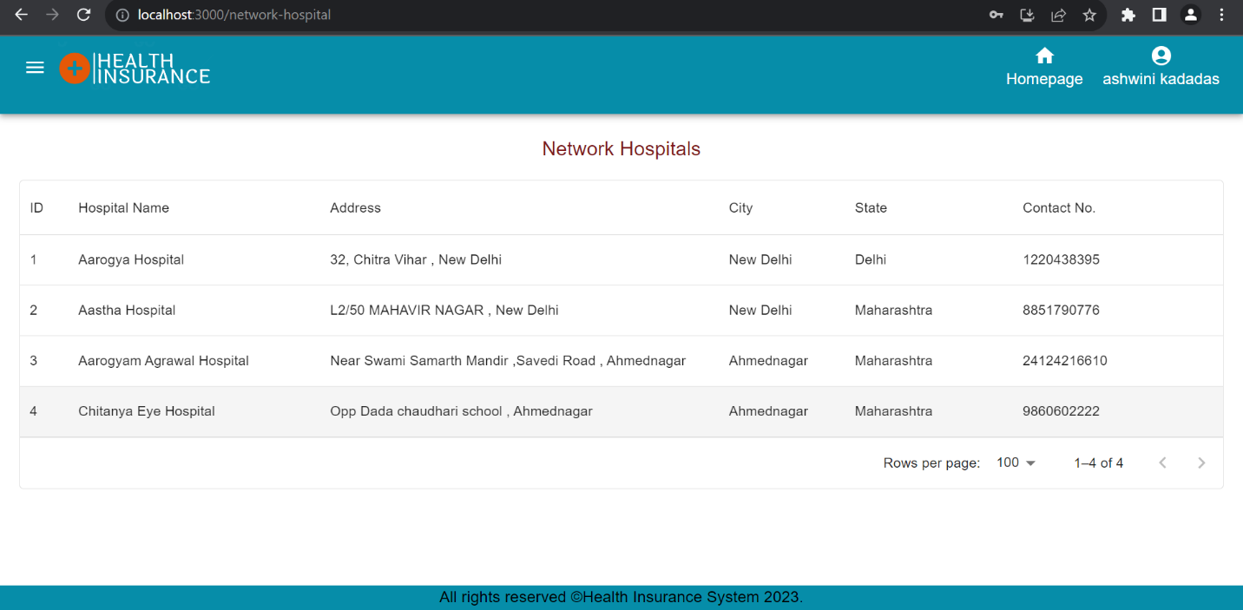

**Add Admin: -** A admin and add another admin by entering all required details of another admin or users. Admin can select a role as admin or user.

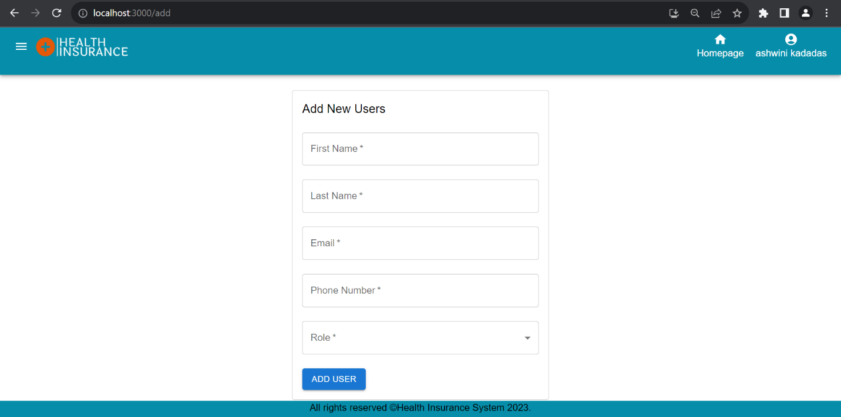

**Reset Password: -** Admin and User can reset the password if they forgotten the old password.

After clicking on forgot the password link present in login page, user and admin can navigate to forgot password page. Here User has to enter correct email Id which is registered with the system. After entering email id and clicking on send OTP button, the OTP will be sent to registered email id.

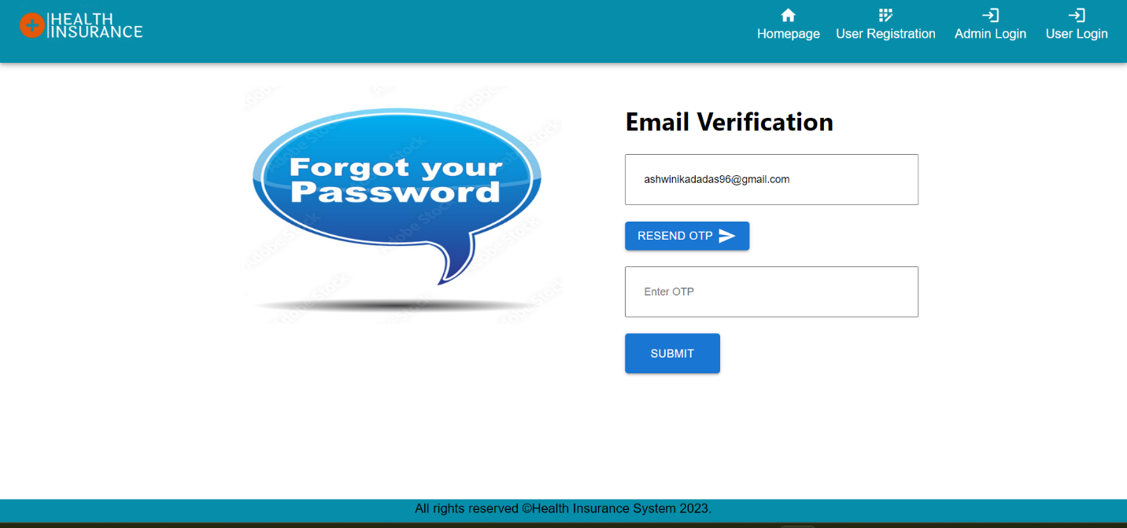

After entering the correct OTP which is sent through registered email id and clicking on Submit button, the new Reset Password page will open. Here user or Admin can reset the Password. After successful resetting password, the new password will updated in database. 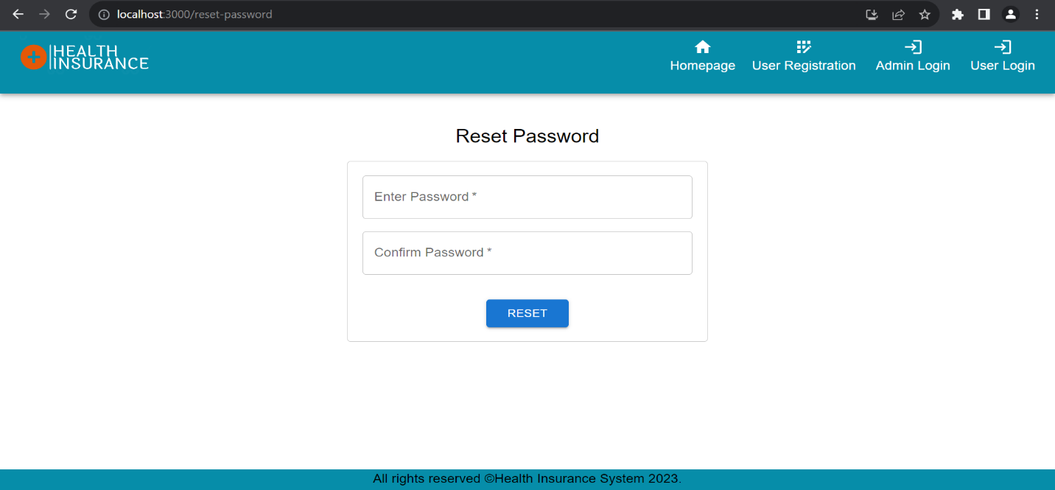

**Backend Implementation :-**

We have implemented Microservice based architecture in the Health Insurance project. Created following services:

1. **Service Discovery**: - One of the main building blocks of a micro-service architecture is service discovery. We have used Eureka service discovery for discovering the network location (IP address and port) of another service to communicate with it.
2. **API Gateway :-** The API Gateway Server is used for **authentication, monitoring, load balancing, caching and request routing.** It routed or proxied the requests to the appropriate service. Provided authentication for different services and their API’s.
3. **User Service: -** User Service is used for accessing the user related information and managing the user. We have provided the JWT Token based user authentication and also email service for sending the email to registered user and also sending OTP to registered user while resetting the password for email verification. In User Service, created different APIs for user and admin login.
4. **Policy Service :-** Policy Service is created for managing and accessing the policy data. Provided JWT Token based authentication for adding, updating and deleting the policy. And also created network hospital new model and APIs for accessing the Hospitals data inside the policy Service.
5. **Userpolicy service :-** Userpolicy service is useful for accessing and managing the userpolicy related data. The policies which are purchased or claimed by particular user that data is handled by userpolicy service. Provided JWT Token based authentication for most of the APIs.
6. **Announcement Service :-** Announcement service is used for making the new announcement and accessing it. Provided JWT Token based authentication for adding the announcement. Only Admin can add the new announcements.
7. **Testimonial Service: -** Testimonial Service is used for managing and accessing the testimonial or feedback related data. JWT Token based authentication provided for updating the data. Only admin can accept or reject the new testimonial feedback given by user. After accepting or rejecting the request, the data will get updated.

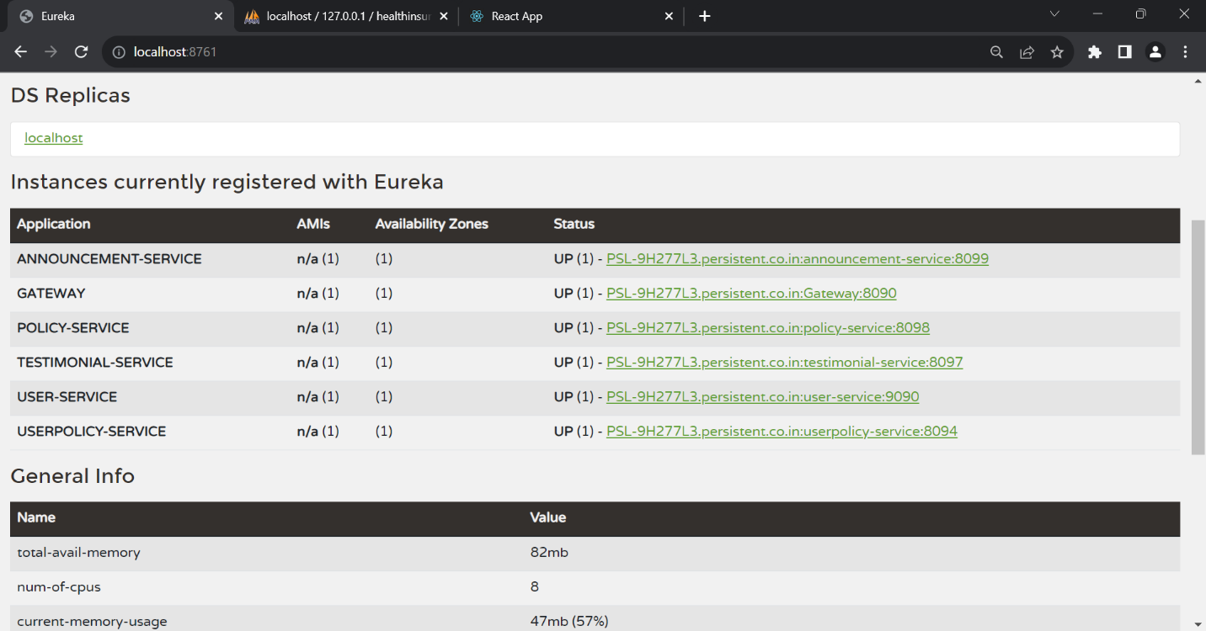

**Email Notifications: -** The Spring Framework provides an easy abstraction for sending email by using the JavaMailSender interface, and Spring Boot provides auto-configuration for it as well as a starter module.

Email is triggered after successful user registration and also after forgot password. To reset the forgotten password, email will be sent to user for OTP Verification.

Here is the email template of our application.

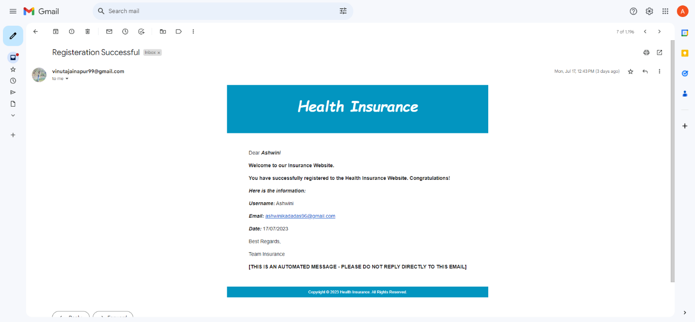

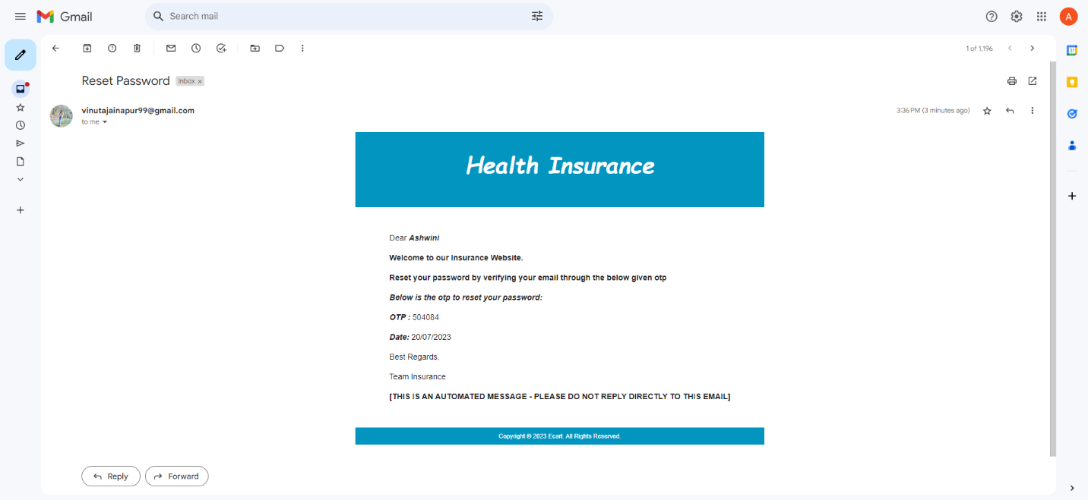

Testing

* **Unit Testing :-**

1) Backend - Junit testing

2)   Frontend - Jest & Cypress

  

**Frontend testing using JEST**

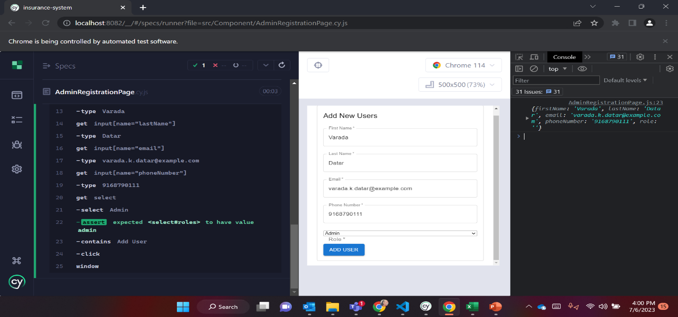

**1.Admin Registration page**

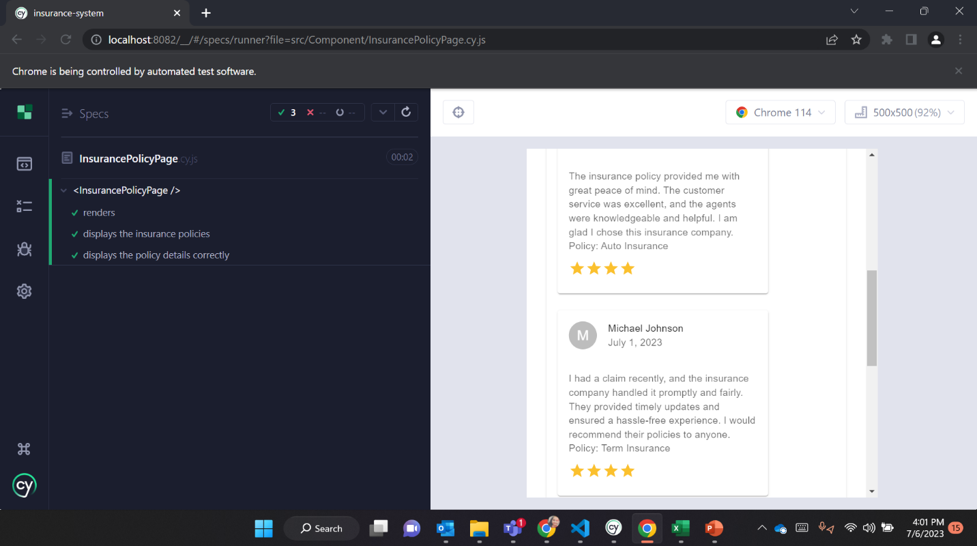

**2. Insurance policy page**

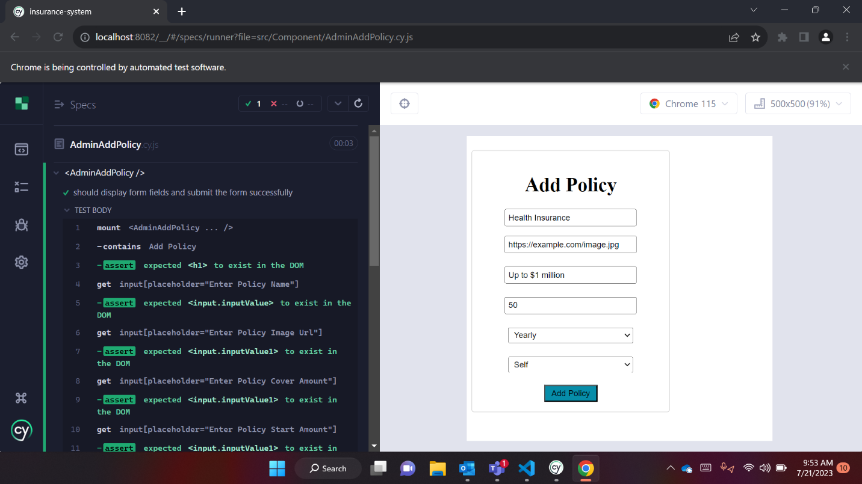

**3.Add Policy Page**

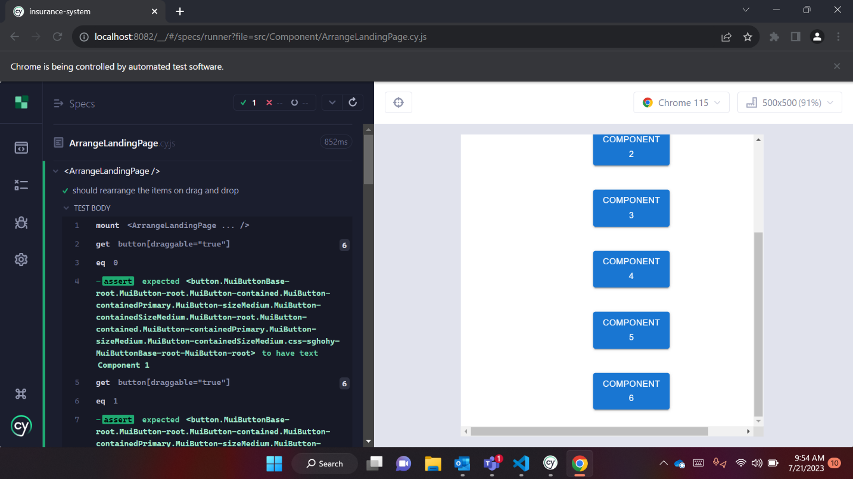

**4.Arrange Landing Page**

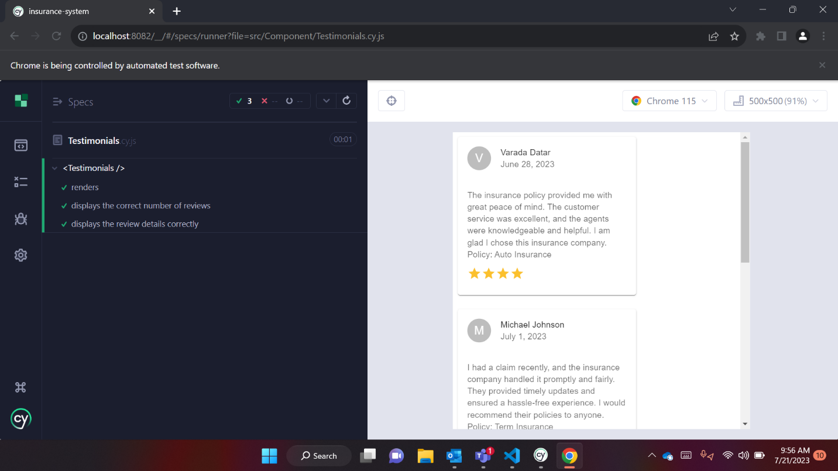

**5.Testimonial Page**

**Backend Testing and Code Coverage part: -**

**1.UserService**

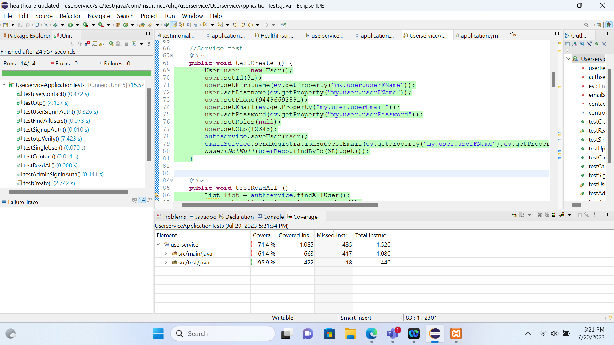

**2.Policy Service**

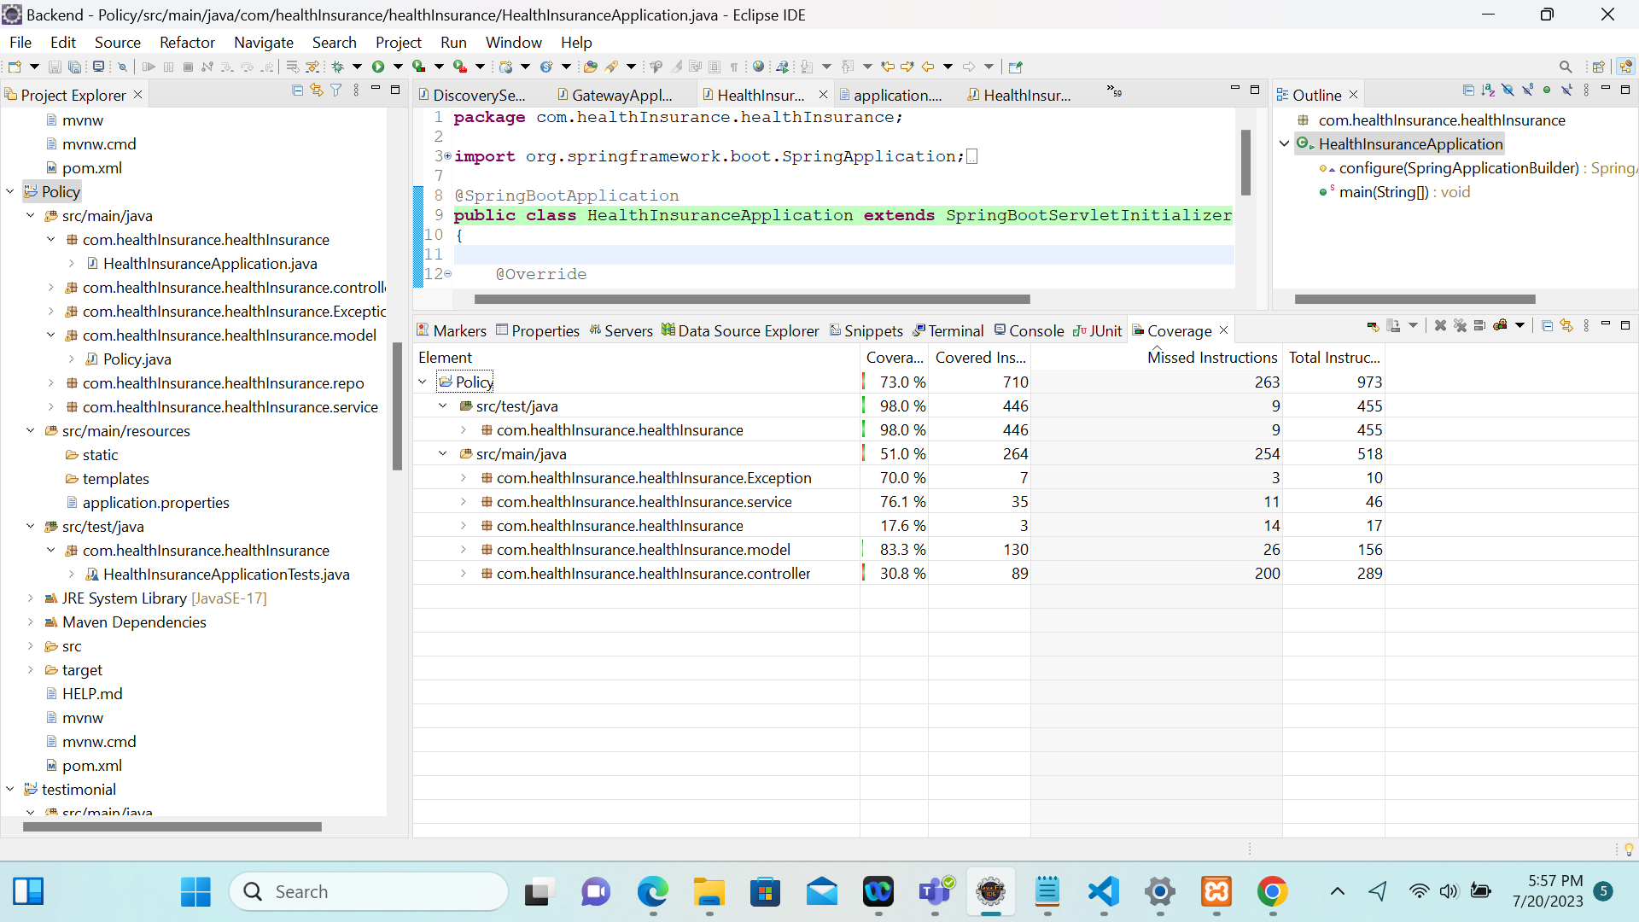

**3.Testimonial Service**

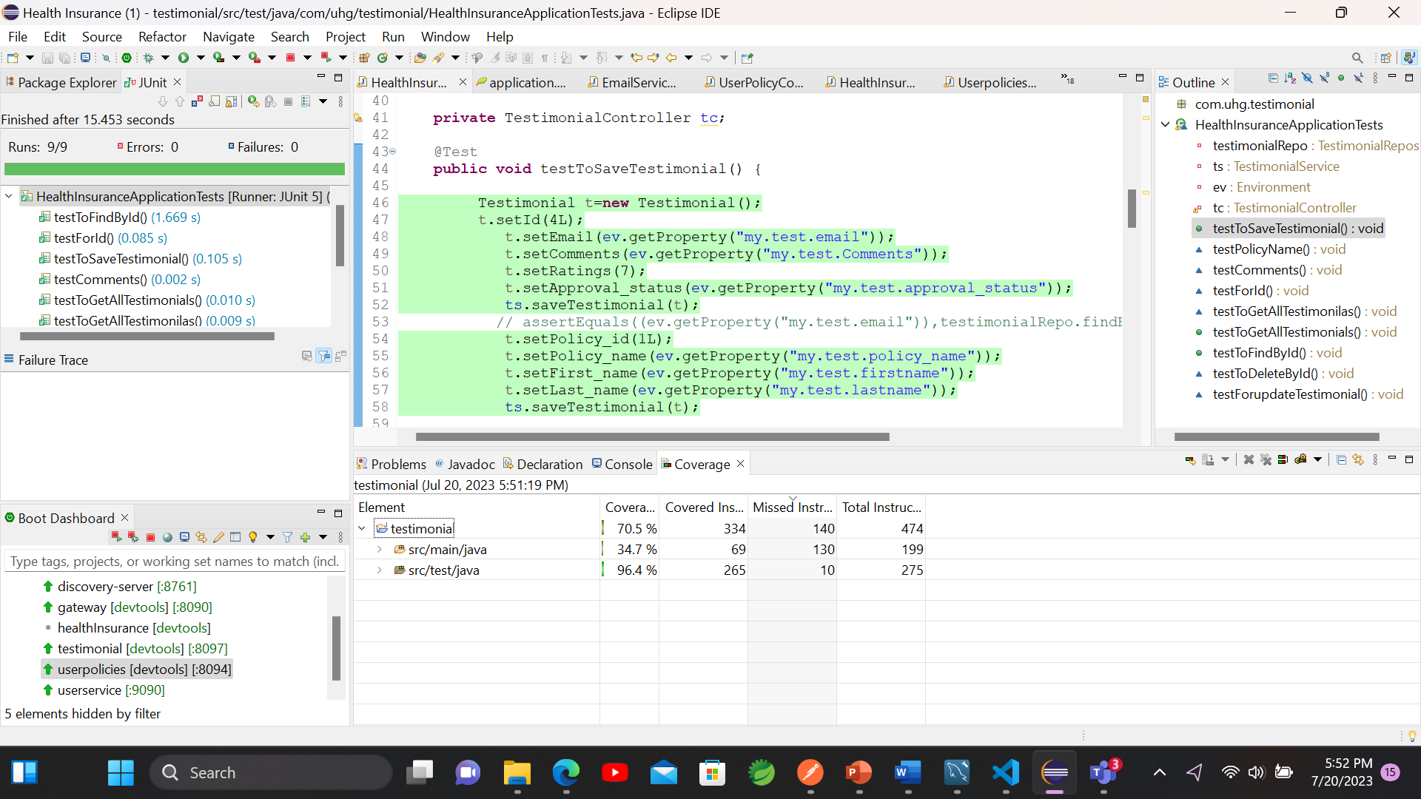

**4.User-policy Service**

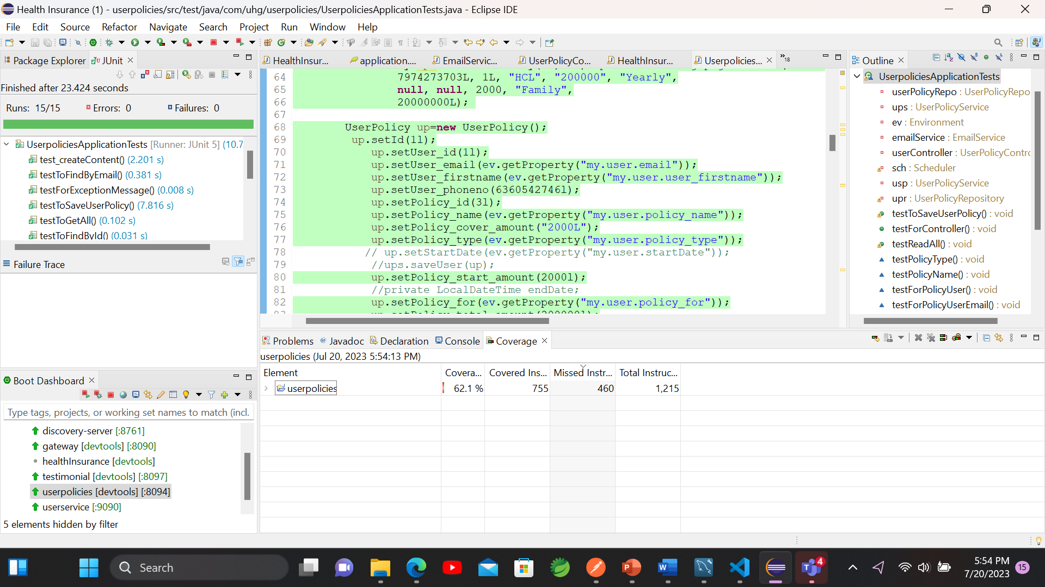

**5.Announcement Service**

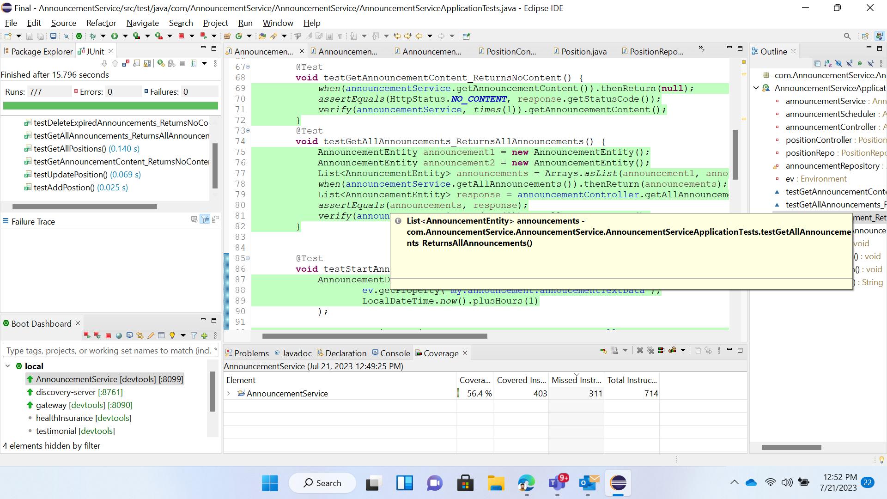

* **Future Scope:-**
* **Personalization and Customization:**Health insurance websites may become more personalized, offering tailored plans and coverage options based on individual health needs and preferences.

Artificial intelligence and machine learning algorithms could analyze user data to suggest suitable plans and make recommendations accordingly.

* **Limitations:-**
* **Lack of Personalized Advice:**

Health insurance websites can provide general information and policy details, they may not offer personalized advice tailored to individual needs. Customers might require more in-depth guidance, especially when choosing complex insurance plans**.**

* **Accessibility Barriers:**Not all individuals have easy access to the internet or are familiar with navigating online platforms. This can exclude certain demographics from availing the services offered on health insurance websites**.**

- - - - - - - - - - - - - - - - - - - - - - - - - - - - - **END** - - - - - - - - - - - - - - - - - - - - - -- - - - - - - -